Sales Analysis with Oracle Analytics Desktop and Autonomous Database

# Objective

This tutorial shows you how to create Sales Analysis with using Oracle Desktop Visualization and data is hosted in Oracle Autonomous Data Warehouse.

# Abbreviation

|  |  |
| --- | --- |
| Oracle Cloud Infrastructure Console | OCI |
| Oracle Autonomous Data Warehouse | ADW |
| Oracle Autonomous Transaction Processing | ATP |
| Oracle Analytics Desktop | DV |

# Background

Oracle Autonomous Data Warehouse (ADW) is fully-managed and offers high performance. It includes all of the performance of Oracle Database in the fully-managed environment that is turned and optimized for Data Warehouse work-load. It means you don’t need to take more effort and resources (DBA role) to manage database and optimize the work-load.

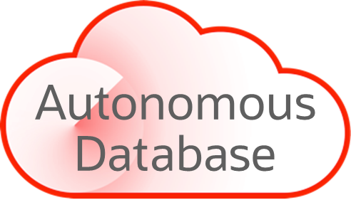

**Self-Driving**

User defines service levels, database makes them happen

**Self-Securing**

Protection from both external attacks and malicious internal users

**Self-Repairing**

Automated protection from all downtime

Oracle Desktop Visualization is a self-service tool to gain insights into your data. It provides standalone data exploration and visualization, it is also the tool for quick exploration of various data sources Excel, CSV, Oracle Database, SQL Server, MongoDB …

# What you need before

* Download the latest version of Oracle Analytics Desktop (version 5.9.0) <https://www.oracle.com/solutions/business-analytics/analytics-desktop/oracle-analytics-desktop.html>
* Follow up the system requirement and instruction before installing the application
* Provision ADW database instance and download ADW Wallet file
* Download the sample file and load data into ADW database instance <https://objectstorage.us-ashburn-1.oraclecloud.com/n/id66dobbdxlj/b/Data/o/Sales_Orders.csv>

# 1-Create ADW connection in DV

* Open DV and click on Create button on the right-top corner
* Create connection

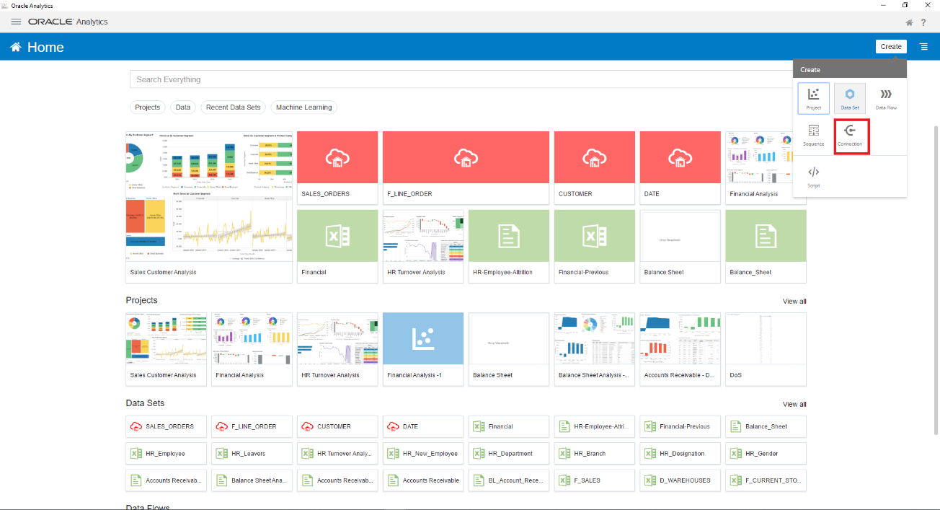

* Create Connection screen appears to allow you to create a connection to various data sources such as Oracle Application, Oracle Database, Oracle Autonomous Data Warehouse, Amazon RedShift, SQL Server,…

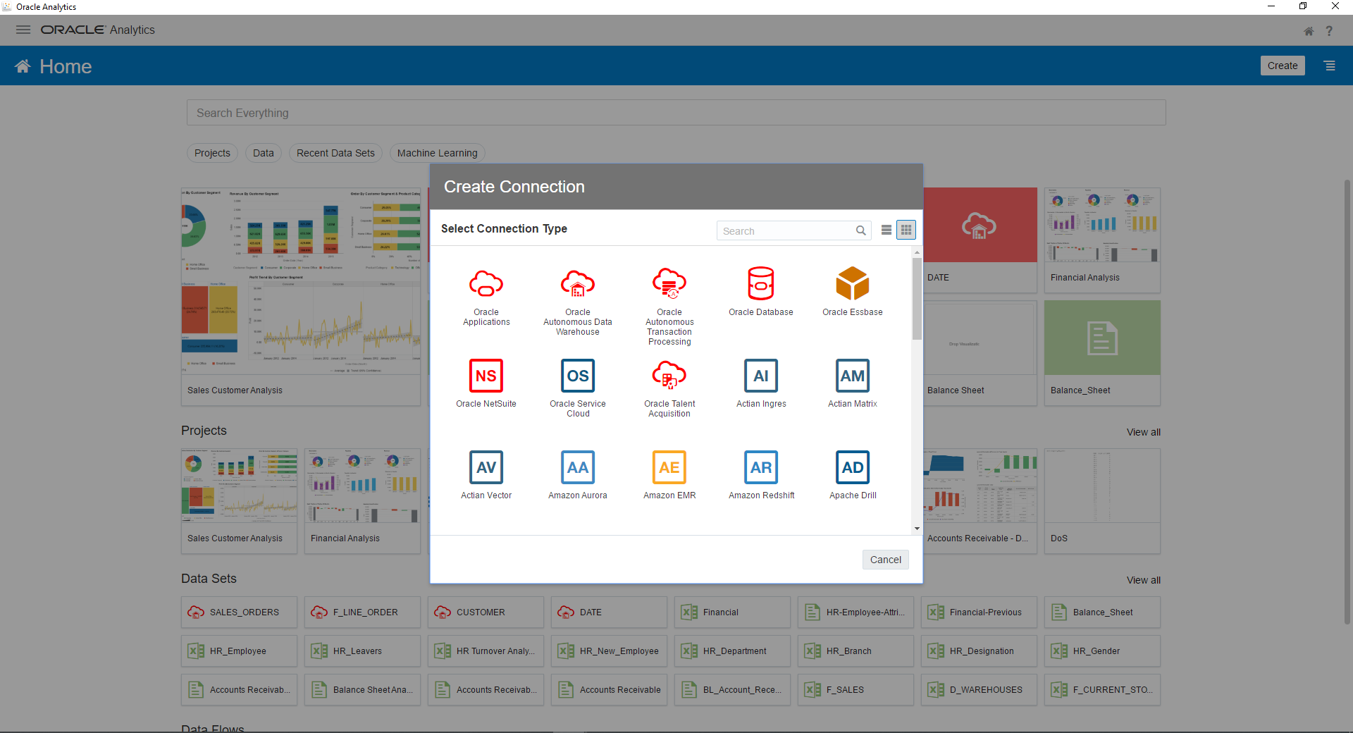

* Choose Oracle Autonomous Data Warehouse
  + Connection Name: SALES_DATA
  + Description: SALES data
  + Client Credentials: browser to the Wallet zipped file
  + Username: enter database username created in ADW database instance
  + Password: enter password of database username
  + Service Name: choose the TNS service name from drop-down list

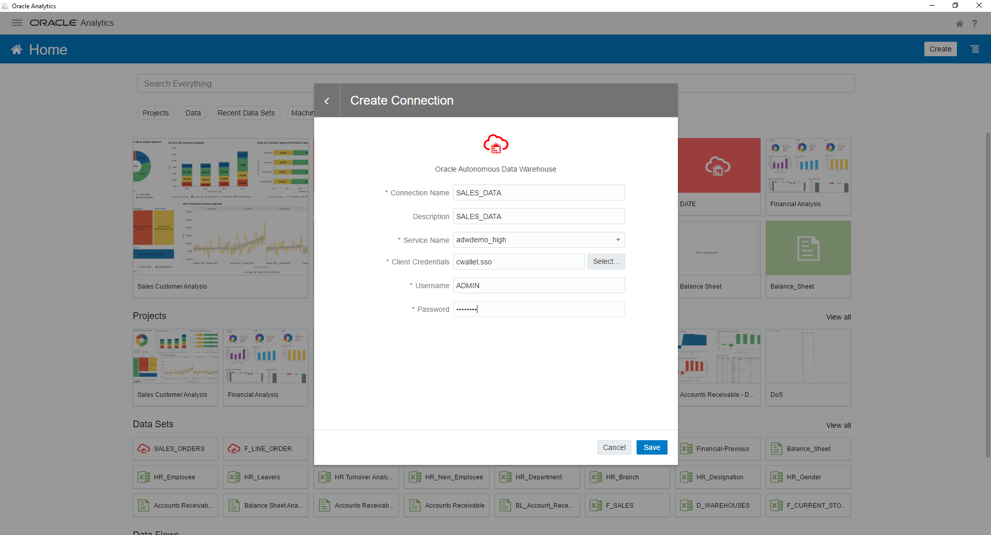

* Click Save and test connection

# 2- Create a dataset from SALES_DATA connection

* After you create the ADW connection, you are able to create datasets that you are working on them to build your reports.
* Click on Create button and choose Data Set
* Create Data Set screen appears and you are able to choose existed connection 🡪 Choose SALES_DATA connection

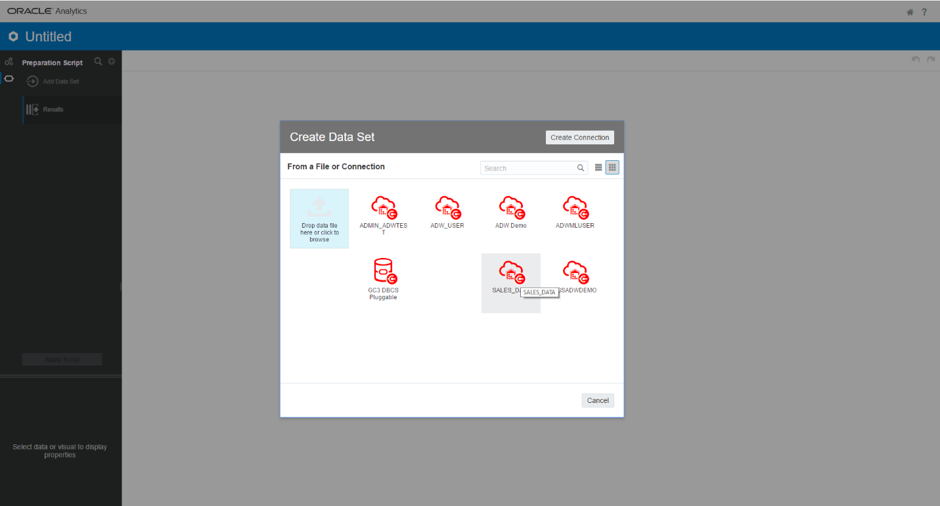

* Because we connected to ADW with ADMIN account, you see all database user schemas in the list. You can choose a database schema that you would like to work. In this tutorial, you choose the DEMO schema initialized when you provisioned ADW database instance.

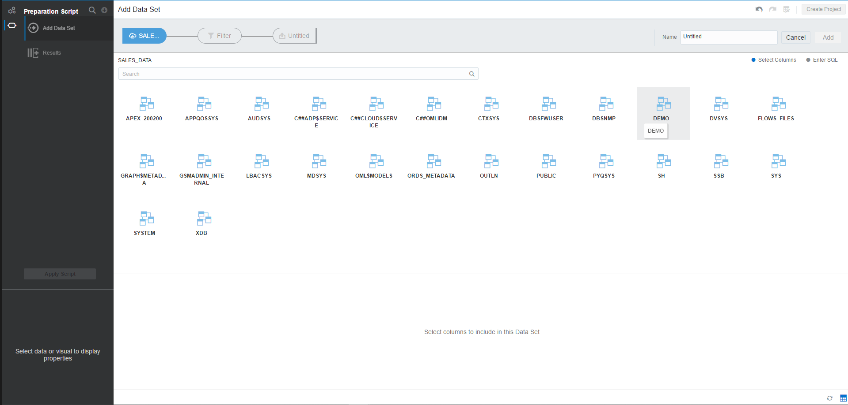

* After database schema selected, it displays list of tables and views in the schema. Enter SALES to filter tables in this schema.

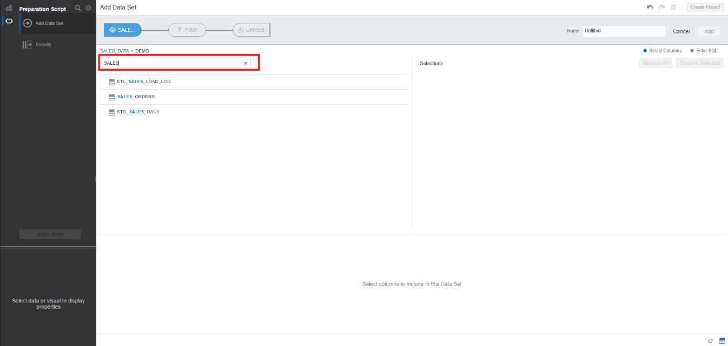

* Choose SALES_ORDERS table 🡪 Add All to choose all columns of this table
* Click Add button to add dataset

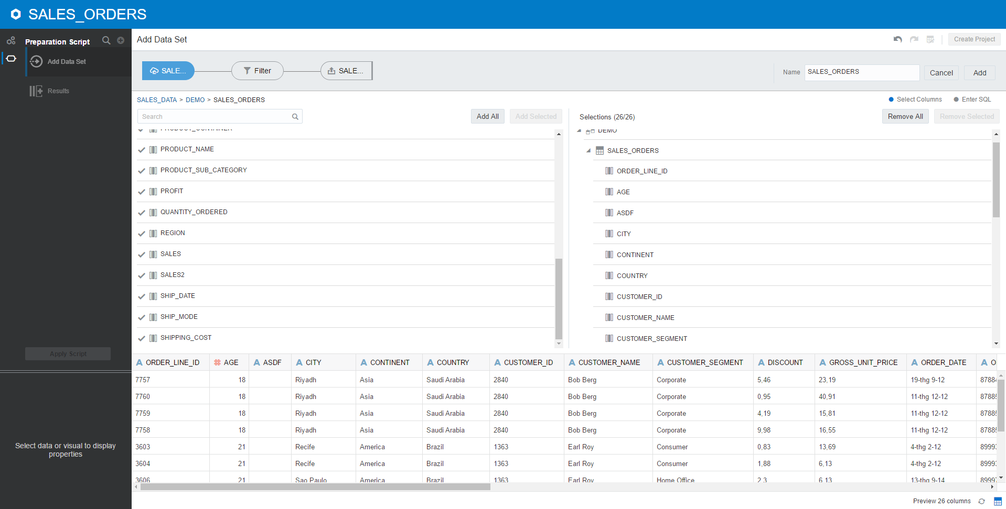

* DV run some processes for profiling your dataset. Then DV provides you some recommendation for data transformations. This is the great feature of DV because it saves your effort on data preparation. On Recommendation panel, DV suggests some data extraction from current columns such as ORDER_DATE, SHIP_DATE, REGION ... Depending on what you want to extract, you can choose any recommendation.

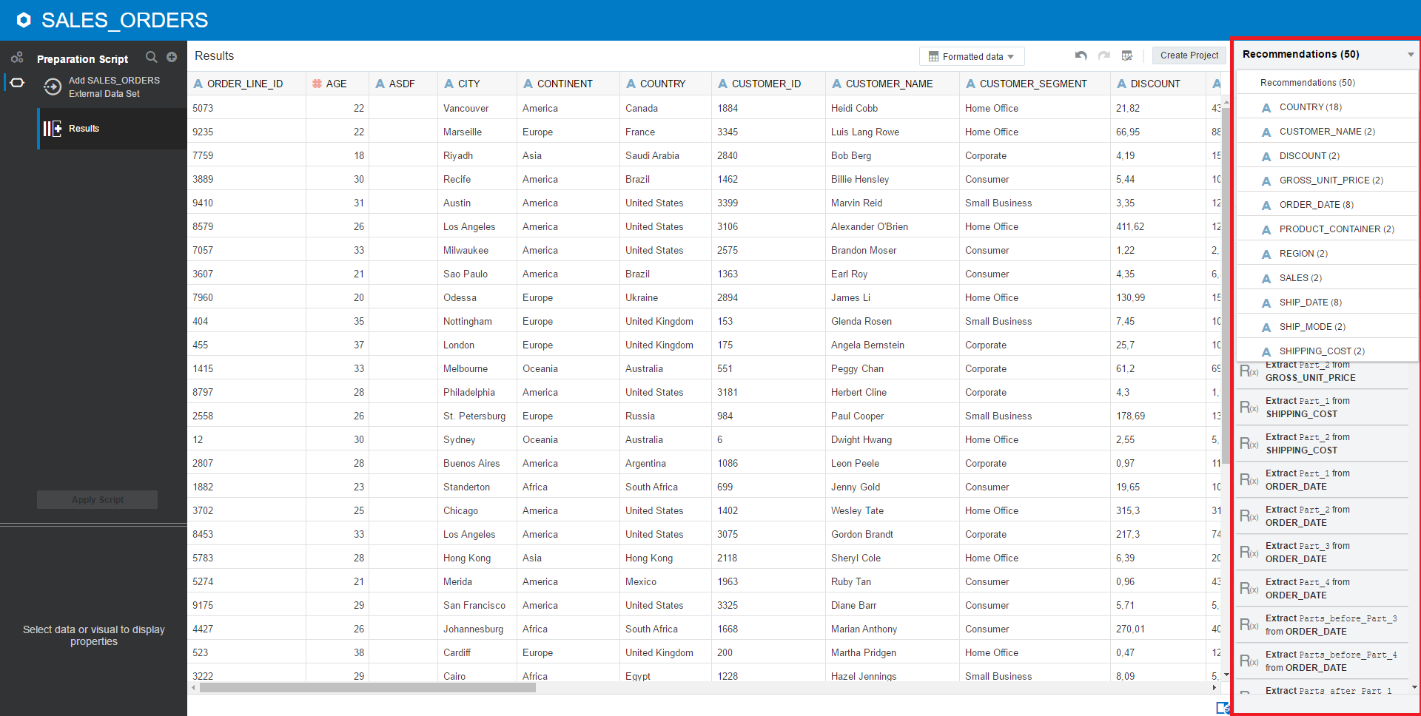

* Choose Formatted metadata in drop-down list. Change the Treat As of following columns as Measure, other columns are Attribute
  + PROFIT
  + QUANTITY_ORDERED
  + SALES
  + DISCOUNT
  + GROSS_UNIT_PRICE
  + SHIPPING_COST
* Change data type of SHIP_DATE and ORDER_DATE to Date

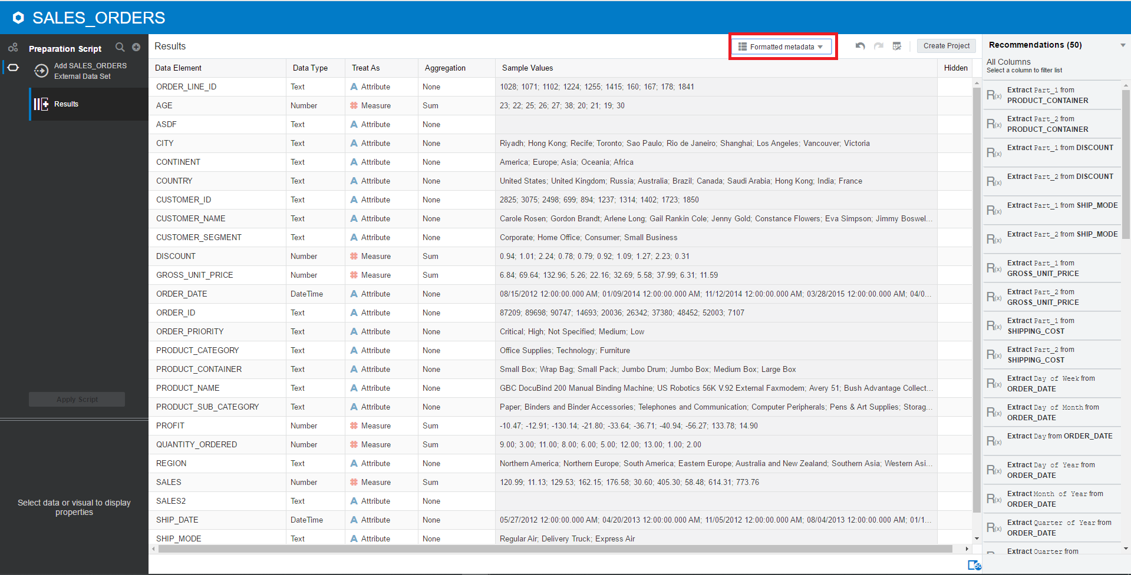

* Rename column to friendly name

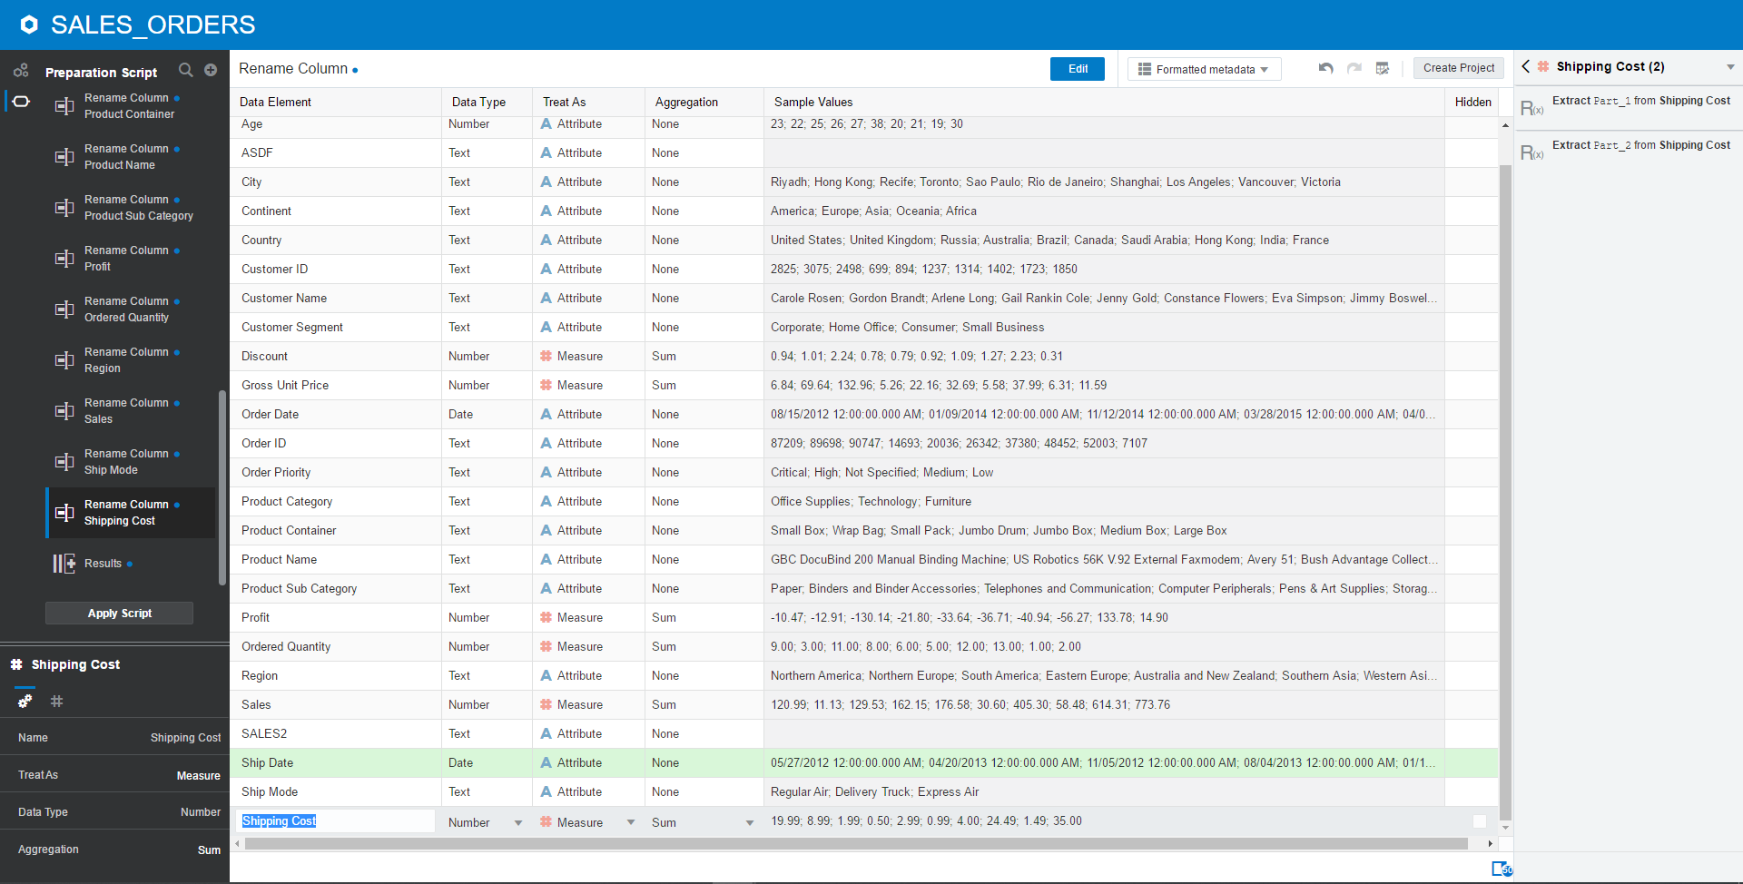

* Click Apply Script

# 3-Create Visualization project

* Click on Create icon 🡪 Project
* Add Data Set screen appears 🡪 Click Cancel. You will add the datasets into project later
* Enter the project name: Sales Customers Analysis
* Click on Add to add datasets

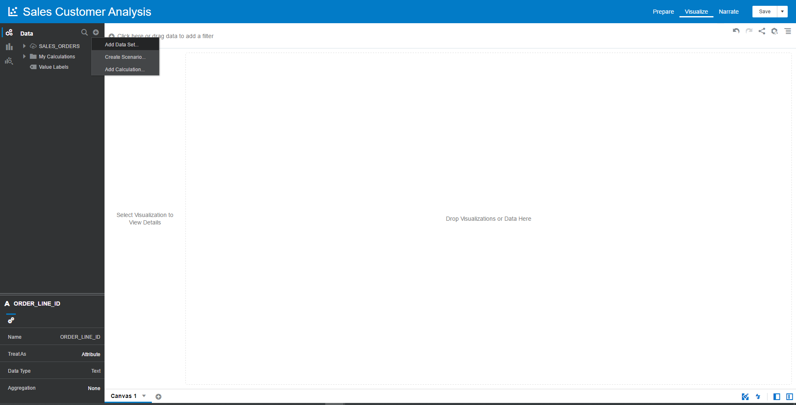

* Choose the dataset created SALES_ORDERS
* Click Add to Project
* Expand My Calculation in dataset to create a new calculation
  + Right-click on My Calculation 🡪 Add Calculation
  + Enter name: Number of Orders
  + Expression: COUNT(DISTINCT Order ID)
  + COUNT(DISTINCT) function is used because the dataset is Line Order Details so we only count unique Order #

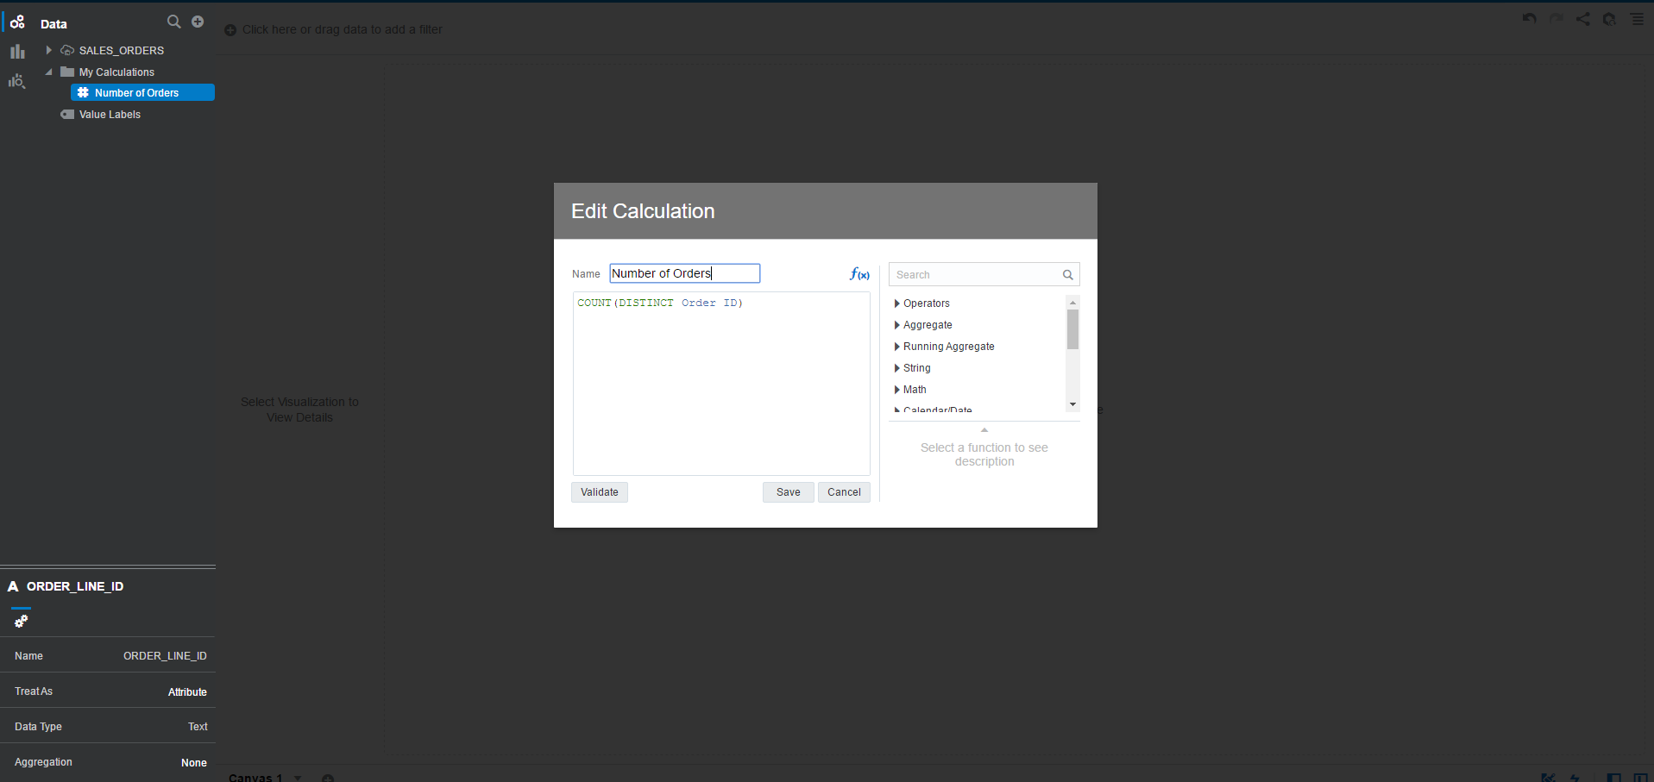

# 4-Build Sales Customer Analysis

## 1-Ordered Quantities Distribution By Customer Segment

* The report to display ordered quantities of all products by Customer Segment
* Chart Type: Donut
* Title Name: Ordered Quantities Distribution By Customer Segment
* Values (Slice): Ordered Quantity
* Category: Customer Segment
* Color: Customer Segment
* Choose Customer Segment and Ordered Quantity from the dataset into Visualization
* Choose chart type: Donut

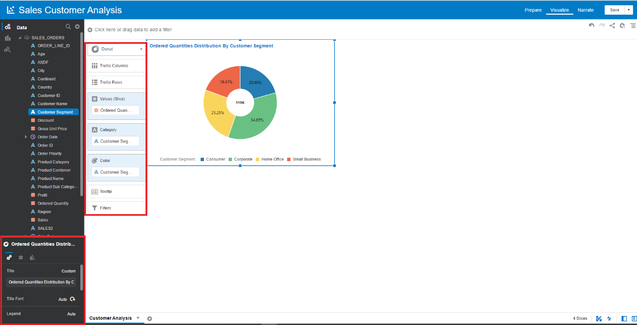

## 2-Revenue By Customer Segment

* The report to display total Revenue by Customer Segment & Year
* Chart Type: Stacked Bar chart
* Title Name: Revenue By Customer Segment
* Values (Y-Axis): Sales
* Category (X-Axis): Year
* Color: Customer Segment
* Choose Customer Segment and Sales and Year of Order Date from the dataset into Visualization
* Choose chart type: Stacked Bar

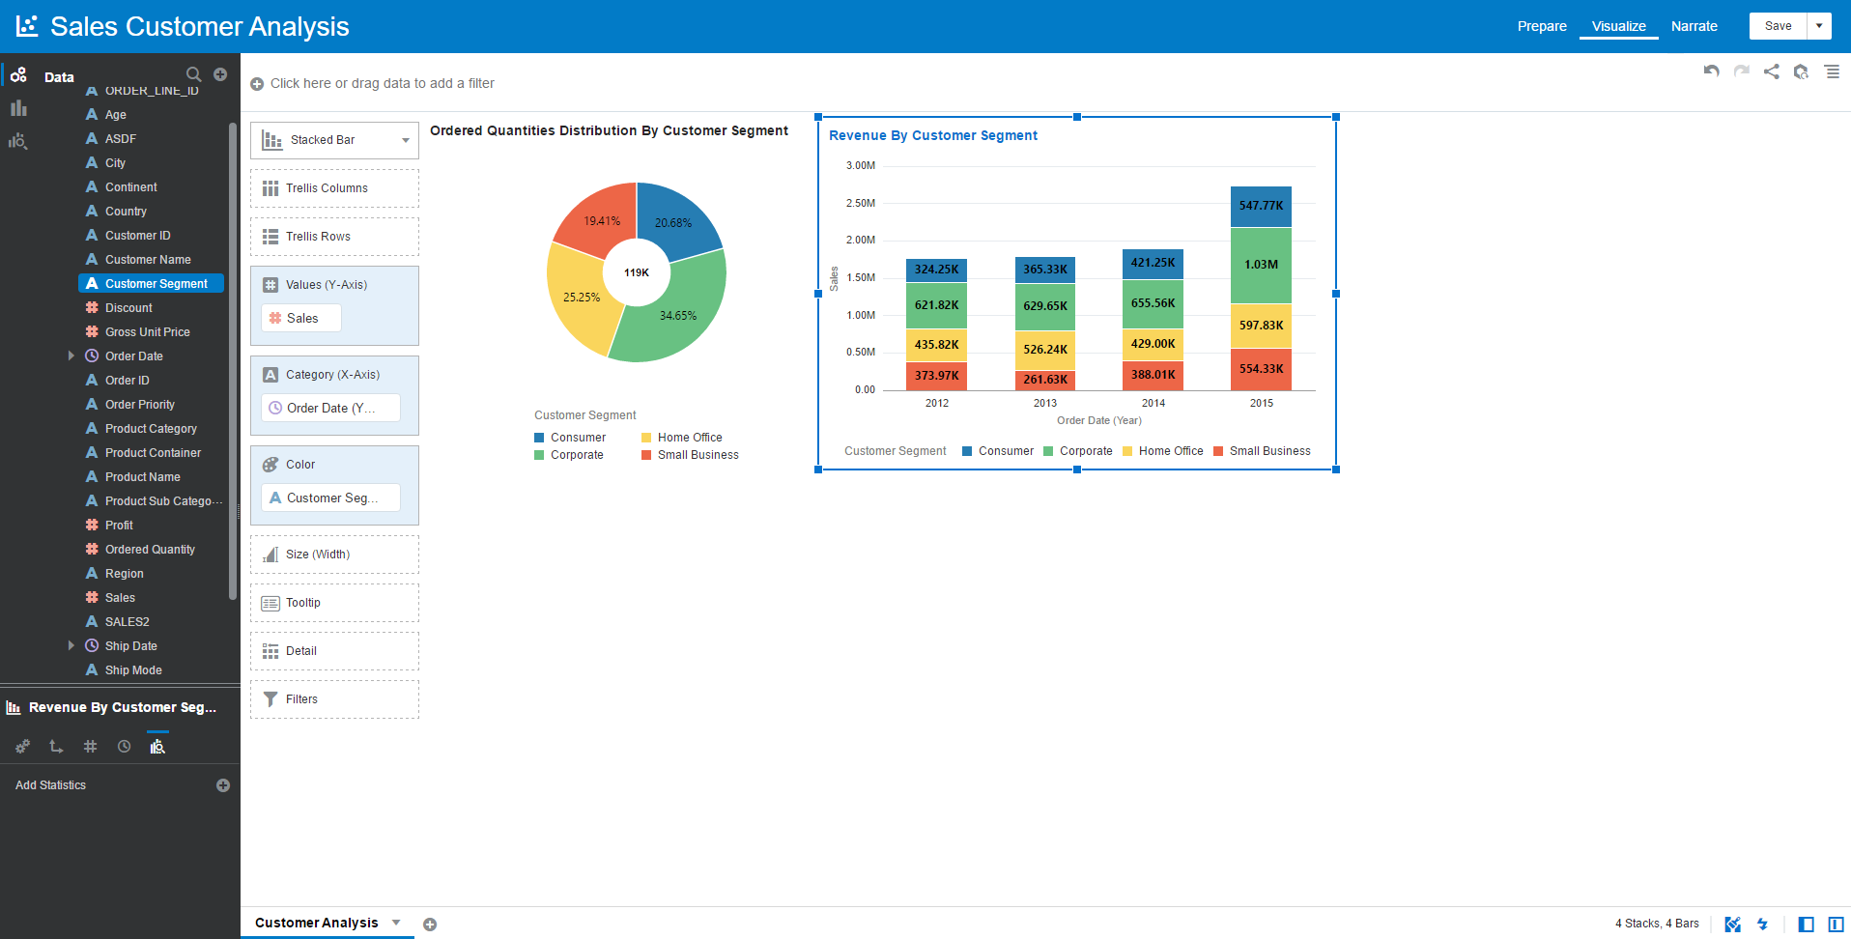

## 3-Profit By Customer Segment

* The report to display total Profit by Customer Segment
* Chart Type: Treemap chart
* Title Name: Profit By Customer Segment
* Values (Box Size): Profit
* Category (Boxes): Customer Segment
* Color: Customer Segment
* Choose Customer Segment and Profit from the dataset into Visualization
* Data Labels: Percent, Value, Label

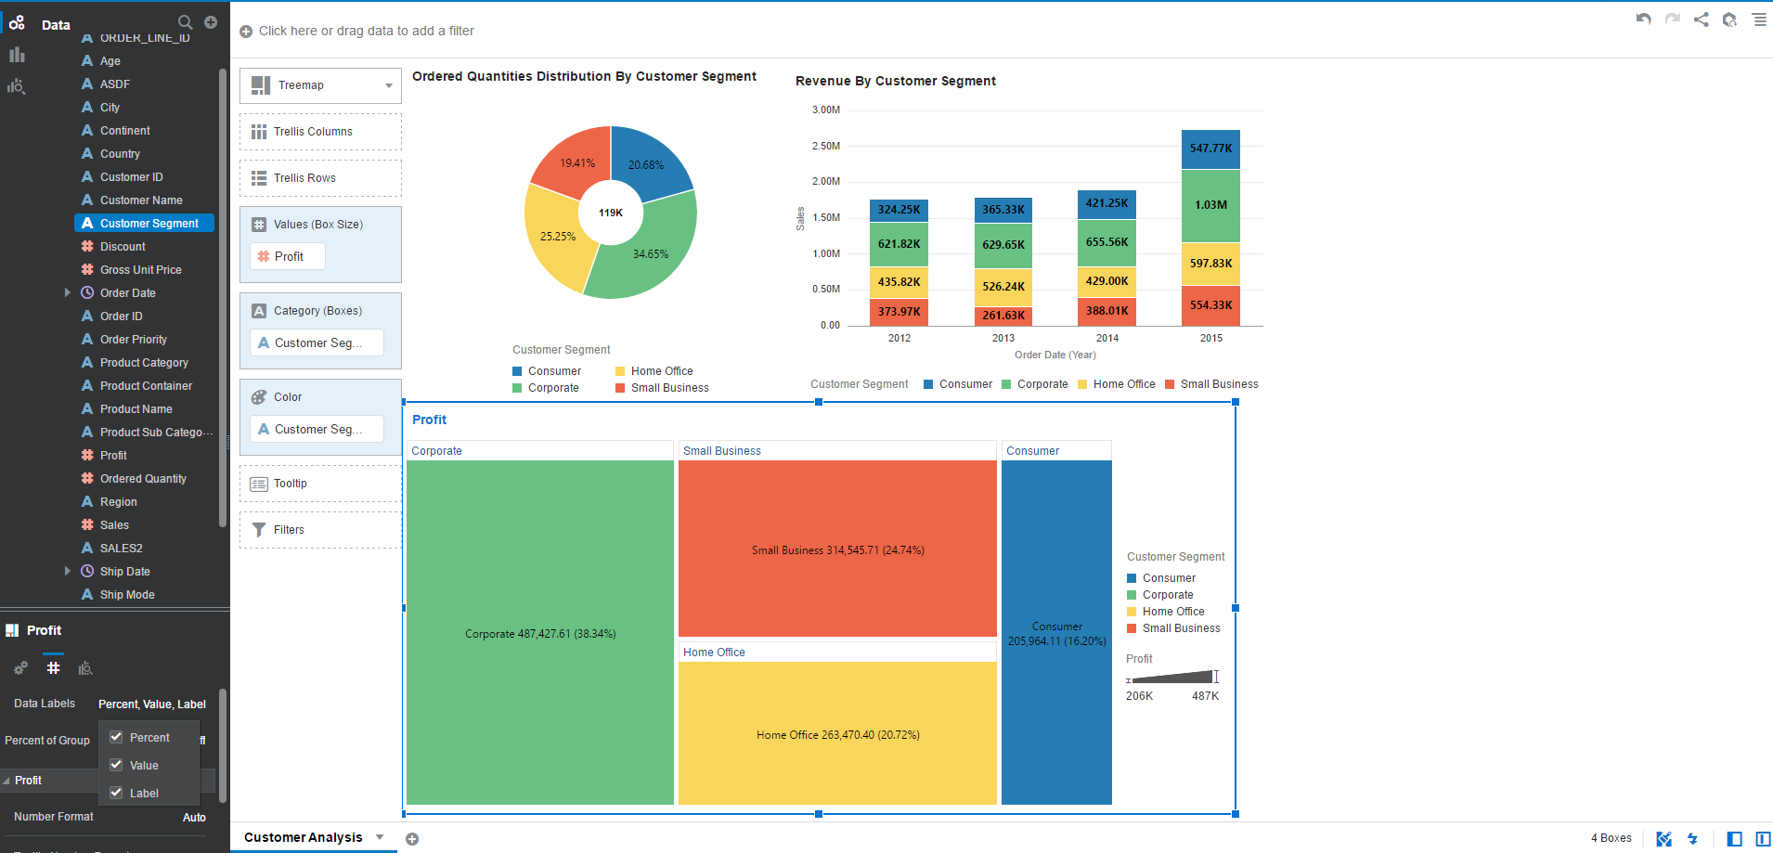

## 4-Profit Trend By Customer Segment

* The report to display Profit Trend by Customer Segment
* Chart Type: Line chart
* Title Name: Profit Trend By Customer Segment
* Trellis Columns: Customer Segment
* Values (Y-Axis): Profit
* Category (X-Axis): Month from Order Date
* Color: Customer Segment
* Choose Customer Segment and Profit, Month of Order Date from the dataset into Visualization
* Add Statistics: add Reference and Trend lines

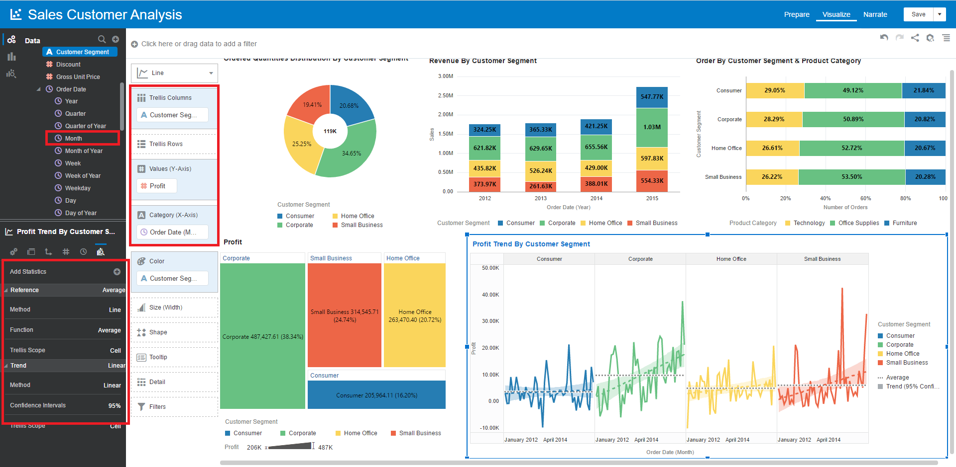

# 5-Add Filter to Dashboard (canvas)

* This step is to create a filter in DV Dashboard (Canvas) in case you want to filter out data in your dashboard such you want to filter out data for Continent, Country and City
* Drag and drop these attributes to top area

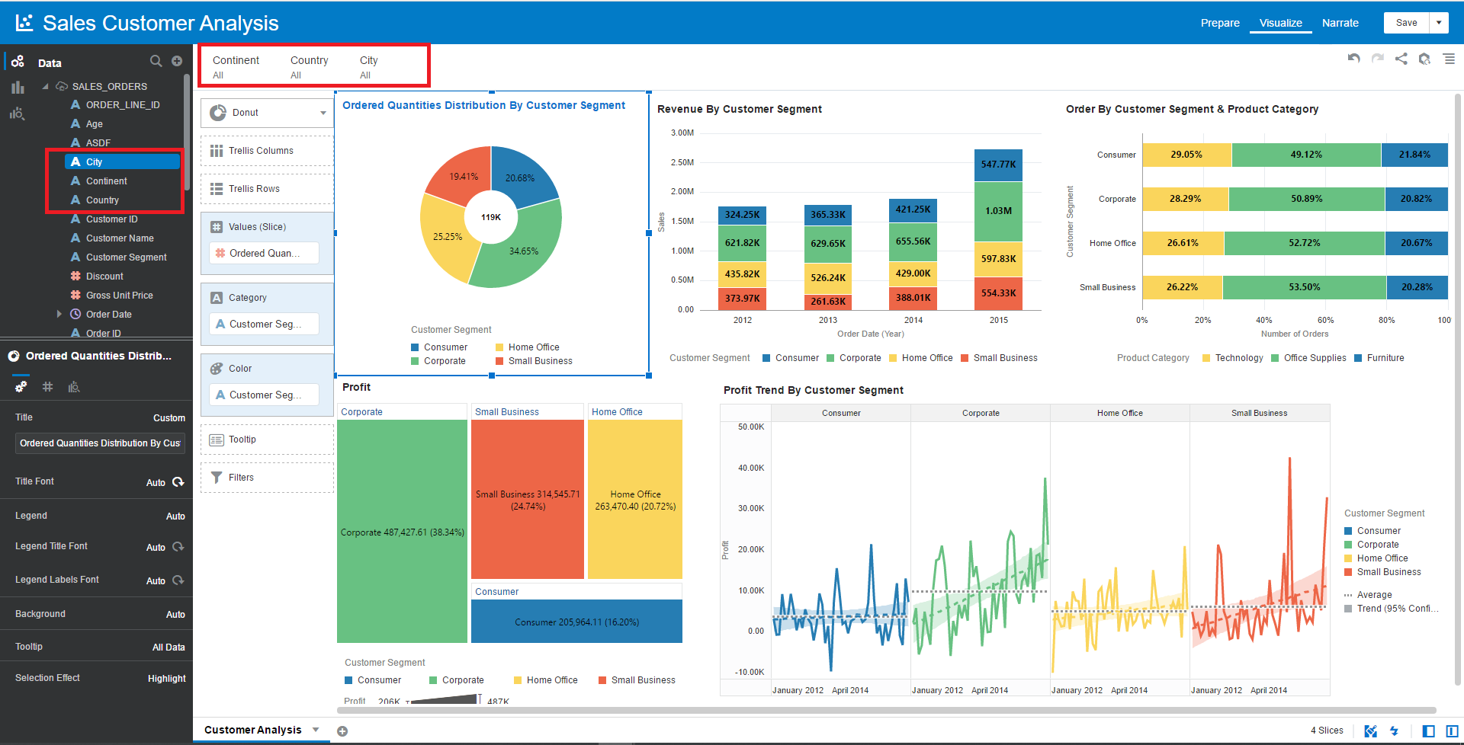

* Click on Country 🡪 Limit Values By 🡪 Continent to create a constraint between Continent and Country. Whenever you choose values of Continent, the countries are only displayed if they are belonged in those continents. In case of Europe continent, the countries of Europe are displayed in Country filter

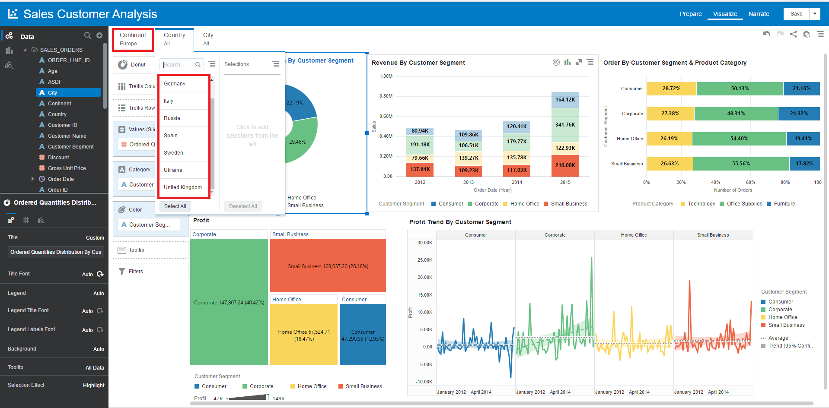

* Apply the same configuration to City filter.
* Let’s try to filter Manchester city

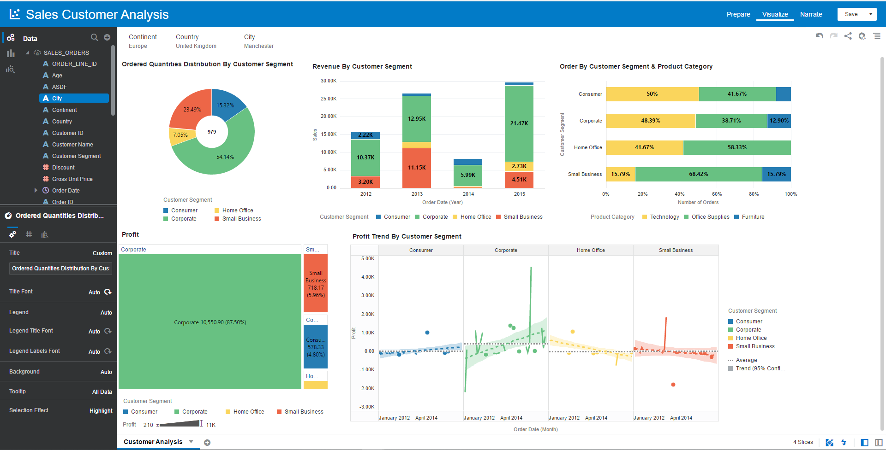

* You can see some abnormal data points for Profit in case of Corporate and Small Business segment. It means you will need to discover more insights in business perspective to find out what happened.

# Conclusion

* Oracle Analytics Desktop is the great self-service analytics tool, it offers a lot of features for basic analytics and augmented analytics. However, Oracle Analytics Desktop is a Java application in client side. It has a limitation of memory (maximum 2GB allocation) so you need to consider if you work with a large dataset.
* Oracle offers Oracle Analytics Cloud platform in cloud that help you on both self-service analytics and enterprise. Besides, if your data is hosted in ADW which the great platform for serving workload of analytics, the platform can provide you the good performance and you can create and analyze your data easily and quickly without requiring more technical effort.